***BIT607***

***Web Development***

***Assessment 2***

***Rogelio Jr Butaran***

***SN: 5048172***

Part 2: Report

1. *Identify and discuss all the security issues website designers should be aware of and give examples of how such security issues were considered when the application was developed. (Word count guideline: 200 words).*

Developers should ensure that security is a main concern for any application development. Sensitive data exposure is one of the security risks. Sensitive data may be compromised without extra protection such as encryption at rest or in transit. In the Restaurant website, one of the website pages is the privacy statement. In this statement includes the purpose of user personal information collection when making a reservation. They also have the option not to give their information, but online reservation won’t be a possibility. Data transit between the client and the browser is vulnerable to a hacker or modification via a man in the middle attack. This risk can be avoided by using HTTPS, the secure version of HTTP. This set up a private connection between the user and the website that hackers cannot easily get through.

Another security risk is denial of service. This is a hacker attack with the intention of harming your business. DoS is an attack that prevents legitimate customers from accessing your business website. One recommendation on how to prevent this attack is by using a server that can handle large numbers of requests but the downside of this is the cost. Another option is to use a content delivery network (CDN). Not only can CDN improve security but also improve website performance because they can deliver pages to users from the nearest server. They also offer additional security services, like protection against some of the OWASP threats faced by server-side web applications.

1. *Explain how HTTP caching and content delivery networks could further improve responsiveness. (Word count guideline: 200 words).*

With HTTP caching, resource fetching can be increased even without internet or network connection. It not only increases the response speed of the application but also lessens the pressure from the server. Different cache types are selected according to different response types. Network conditions are unreliable so HTTP catching can greatly improve application performance, especially when the response content is large.

Content delivery network or CDN is a method of sending content from a website or mobile application to people more quickly and efficiently based on their geographical location. A CDN is made of a network of servers in locations all over the world. Once the user is connected to these servers it will ensure the best possible online experience including the responsiveness of the website that the user is looking at. Anybody who has a website like the Restaurant website that’s included in this assignment can benefit from a CDN. Some of these benefits include faster load times for web and mobile users, quickly scalable during times of heavy traffic, better site performance, decreases infrastructure cost due to traffic offloading and minimizes the risk of traffic spikes at point of origin, ensuring stability.

1. *Identify all principles of responsive design with reference to examples from your application that demonstrate how it provides for a better user experience.*

When designing a website there are many factors that a developer should consider. A well-designed website can help the user to establish trust and act. Creating a good user experience includes making sure your website design is optimized for usability and how easy it is to use.

Focus on screens and not on devices. There are many screen sizes available now, developers should focus on who is their focus. On the restaurant website, the focus is people who use desktop and mobile phones. So the website responsive design in based on these focused market.

Put the same effort into designing smaller and larger screens. HTML codes have been altered for the website to work on both desktop and mobile screens as each user deserves a pleasant user experience whenever they are visiting the website no matter how big or small their screens are.

Don’t hide the content. Users should be getting all the information from the website either they are using mobile phones or desktop/laptop. People nowadays use their mobile phones to access websites and search online so they always assume that they will see all the information that they are looking for no matter what device they are using.

1. *Extensions in Visual Studio are add-ons that allow you to add new features or to increase productivity and improve your workflow. Go to the Visual Studio Marketplace and install two extensions. Test these extensions for their functionality, then evaluate the tool based on its usefulness. You may include screenshots to demonstrate how these tools were used.*

**LIVE SERVER ADD-ONS**

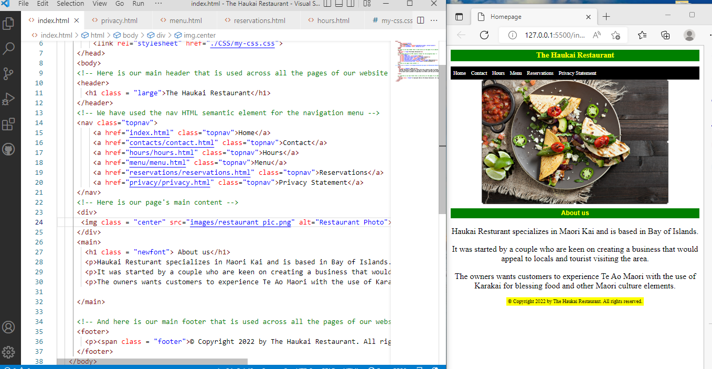

Live server is a good VS code extension as every time you save your code, you’ll instantly see the changes reflected in the browser. You’ll be much faster in spotting the errors and it’s much easier to do some quick experiments with your code.

**COLORIZE**

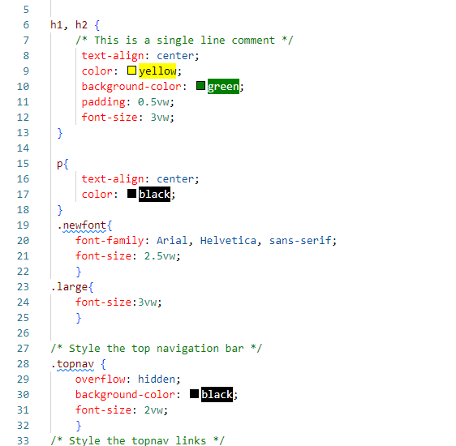

Since I considered myself a beginner in coding, this extension helps me to visulaize color when im doing my CSS code. This makes it easy to see immediately which color that I am using, thus increasing my productivity and improving my workflow.

1. *Document all the steps that you have taken to test your application’s network performance, using Chrome’s Development tools. These steps should demonstrate how you evaluated page load times, and any actions taken to improve page loading times and any further tests that were carried out. You may include screenshots that demonstrate how this tool was used.*

First is to make sure that your website is working. This is my website for this assessment:

<https://rogelio101.github.io/Haukai.github.io/index.html>

Open the website on chrome and then open the network and rendering performance tool by pressing F12.

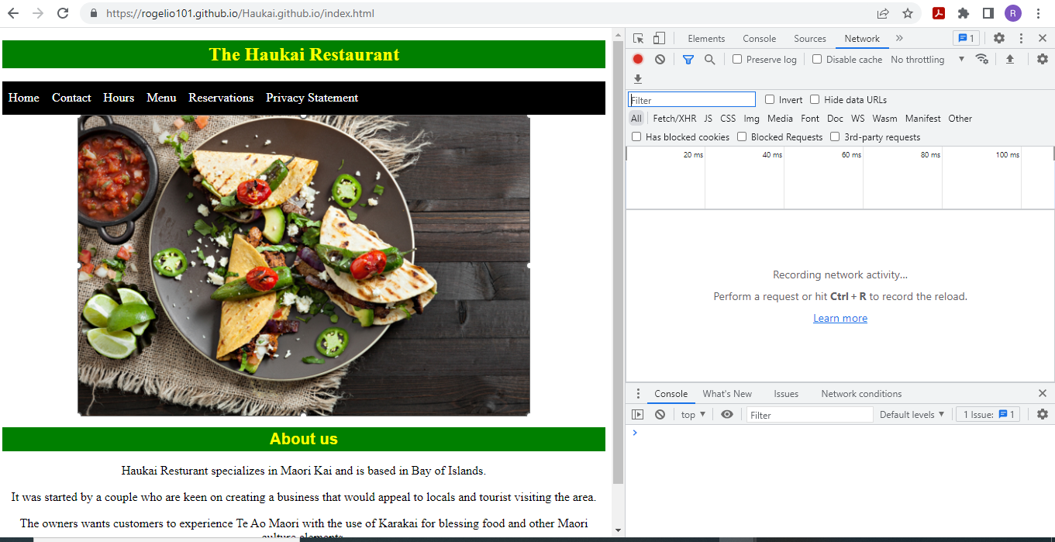

Check the loading speed of the website.

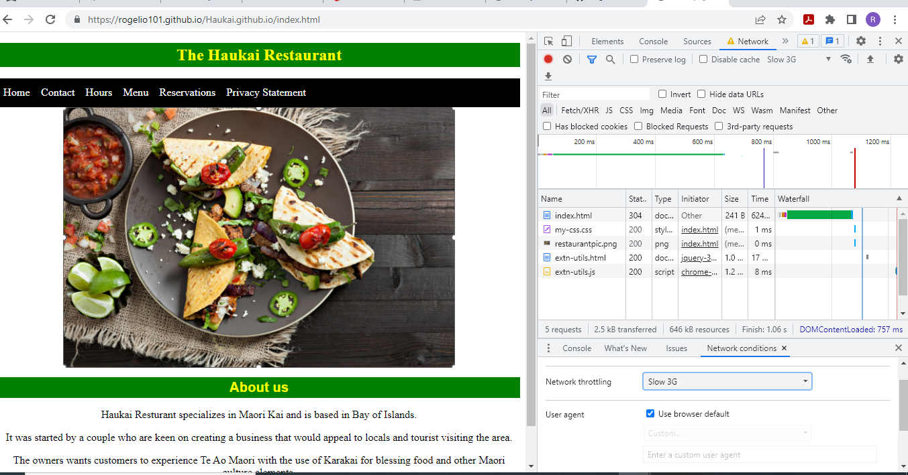

I’ve also used online tools for speed check. I’ve used Google Page Speed Insight.

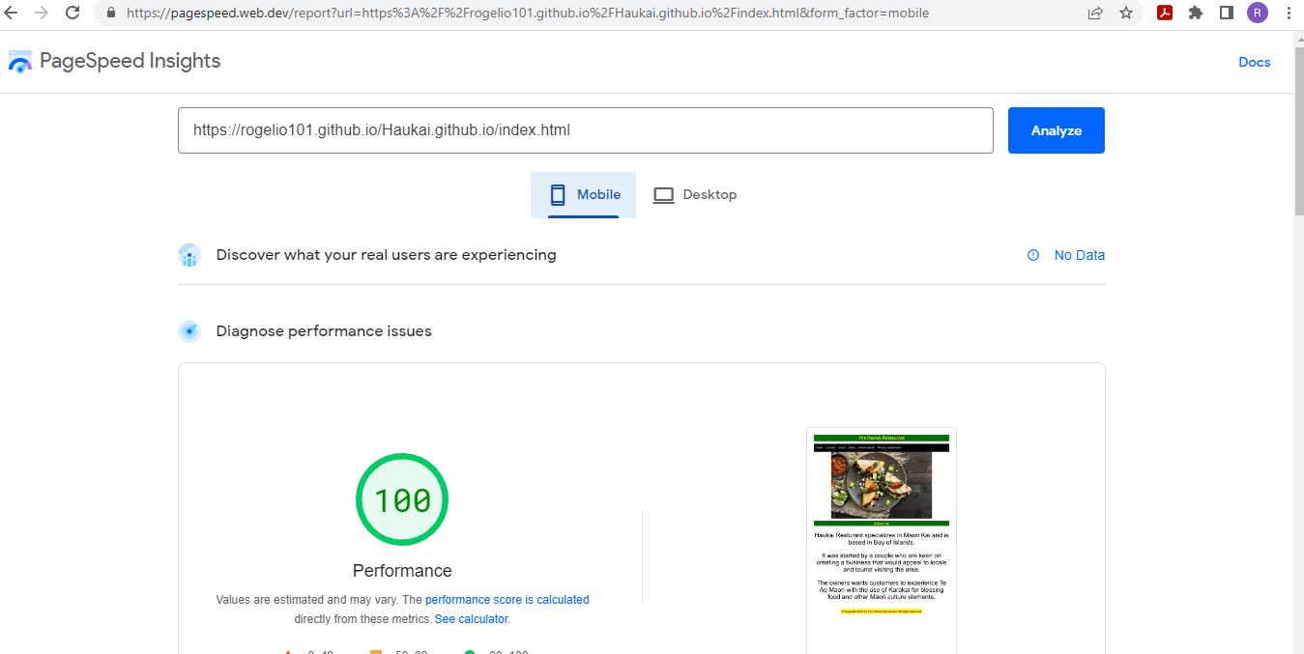

And the Pingdom, to test my website page speed from different location.

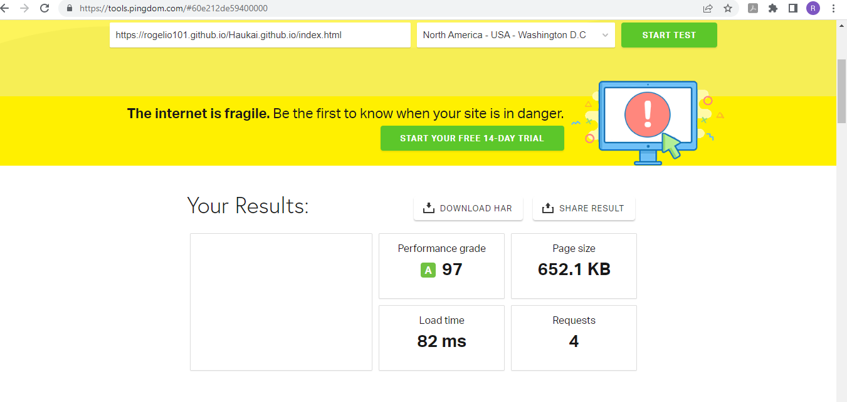

REFERENCES

Open polytechnic. (2022). *BIT607 Web Development.* [*https://openpolytechnic.iqualify.com/course/-N4QHdPt0vARZnfTT5KY/#/overview*](https://openpolytechnic.iqualify.com/course/-N4QHdPt0vARZnfTT5KY/#/overview)

W3school. (2022) *HTML Responsive Web Design.* <https://www.w3schools.com/html/html_responsive.asp>

Lee, Z. (2022, July 13). Web Application Performance Optimization – HTTP Caching. <https://blog.devgenius.io/web-application-performance-optimization-http-caching-791eeda4509e>

Perez, M. (2015 March 2). *What is a CDN and Why you should use one.* Fastly. <https://www.fastly.com/blog/why-you-should-use-content-delivery-network>

Duran, A. (2018, September 12). *Responsive Web Design: Our 5 proven principles.* Level-Level. <https://level-level.com/blog/responsive-web-design-our-5-proven-principles/>